Name: Quang Huynh Date: _____________

Algebra 2H: Unit 11 – Sequences and Series Unit Exam

**Part I: Answer all questions in this part. Each correct answer will receive 2 credits. No partial credit will be allowed. Write your answer choice in the space provided.**

__________1. What is the common ratio for the geometric sequence 6, 2, , …?



(1)  (3) 3

(*2*)  (4) 1



__________2. What is the third term of the recursive sequence below?

$a_{1}=-6$ $$a_{n}=\frac{1}{2}a_{n-1}-n$$

$$a_{2}=\frac{1}{2}(-6)-2$$

$$a_{3}=\frac{1}{2}(-5)-3$$

(1)  (3) 



(2)  (4) 



__________3. What is the value of  ?



(3-1)2 + (4-1)2 + (5-1)2 + (6-1)2  = 54

(1) 54 (3) 90



(2) 196 (4) 4

__________4. How is the series 2 + 5 + 8 + … + 299 written in sigma notation?



(1)  (3) 



(2)  (4) 



_________5. What is the sum of the first five terms of an arithmetic series if the first term is 6 and the common difference is 2?



(1) 20 (3) 25

(2) 10 (4) 14



_________6. What is  for the geometric sequence 3072, 1536, 768, 384, …?

(1) 3 (3) 0.5



(2) 6 (4) 12



__________7. What is the sum of the first seven terms of the geometric series 3 + 6 +12 + …?

(1) 189 (3) 99

(2) 765 (4) 381



__________8. A geometric series whose first term is 3 and whose common ratio is 4 sums to 4095. The number of terms in this sum is



(1) 8 (3) 6



(2) 5 (4) 4



__________9. A sequence is defined recursively by the formula  and . Based on this definition, what is the summation ?

(1) 370 (3) 220

(2) 250 (4) 448



_________10. What is the common difference of the arithmetic sequence below?

7*x*, 4*x*, *x*, 2*x*, 5*x*, …

(1) 3 (3) 3

(2) 3*x* (4) 3*x*



_________11. The summation  has a value of

1. 1 (3) 3
2.  (4) 0

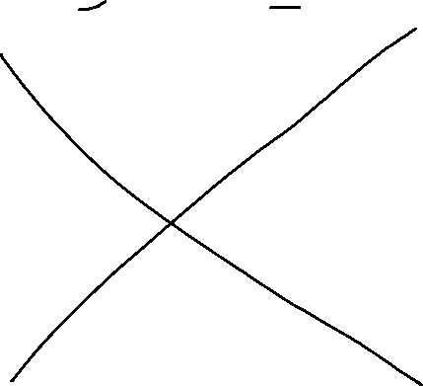

_________12. What is the sum of the infinite geometric series whose first term is 100 and whose fourth term is ─0.8?

(1) 125 (3) 

(2) ─125 (4) 



_________13. A sequence has the following terms: , , , and . Which of the following represents the *n*th term in this sequence?

1.  (3) 
2.  (4) 



**Part II: Answer all questions in this part. Each correct answer will receive 2 credits. Clearly indicate the necessary steps, including appropriate formula substitutions, diagrams, graphs, charts, etc. For all questions in this part, a numerical answer with no work shown will receive only 1 credit.**

14. Express the following sum using sigma (summation) notation. Use *i* as your index variable.





15. For an arithmetic series that sums to 1,242, it is known that the first term equals 7 and the last term equals 85. Determine the number of terms summed in this series. *Only an algebraic solution will receive full credit.*



16. If a geometric sequence is defined by a first term of  and a common ratio of , then find the sum of the first ten terms of this sequence.



**Part III: Answer all questions in this part. Each correct answer will receive 4 credits. Clearly indicate the necessary steps, including appropriate formula substitutions, diagrams, graphs, charts, etc. For all questions in this part, a numerical answer with no work shown will receive only 1 credit.**

17. Write the first five terms of the sequence for which $a_{n}=2(3^{n-1})$.

6, 18, 54, 162, 486

Is the sequence defined above arithmetic, geometric, or neither? Explain.

The sequence is geometric because it has a common ratio.

18. Write an **explicit formula** for , the *n*th term of the recursively defined sequence below.



an=(x+1)(x)n-1

For what values of *x* would  when *n* > 1?

0=(x+1)(x)n-1

X+1=0 xn-1=0

X=-1 x=0